**HdM** Headtracker

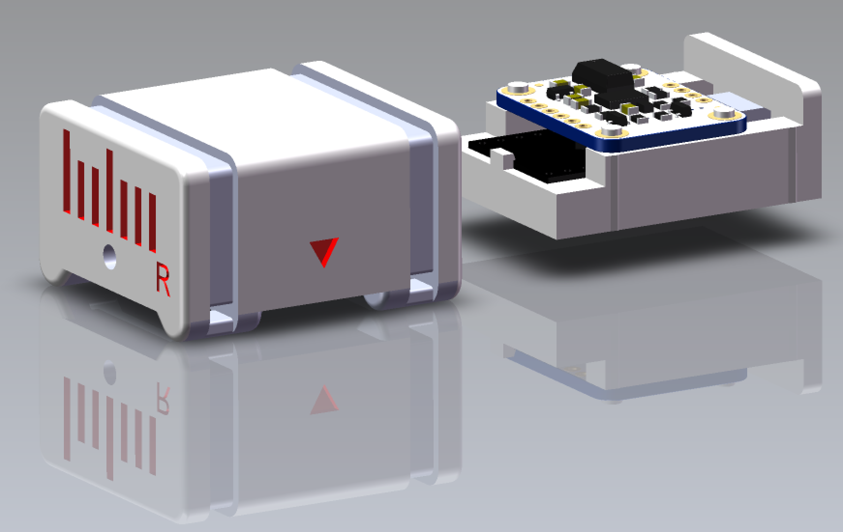

Construction Manual



Project Authors: Prof. Dr. Melchior, Christoph Hafner (ch124),

Steffen Marquardt (sm188), Falko Groß (fg059)

# Manual Index

**Manual Index** **1**

Introduction: 3

**Version 1: The headtracker with case** **4**

**Required Components** **4**

Hardware: 4

Software: 4

Additional Tools: 5

**Building instructions Version 1:** **5**

Step 1: Download the Github repository 5

Hardware (Part 1): 5

Step 2: Print the HdM-Tracker case and drawer 5

Step 3: Check if the Arduino and the sensor fit into the case 6

Step 4: Cut and dismantle jumper wires 7

Step 5: Connect the sensor to the Arduino 7

Step 6: Mount the electronic components to the drawer. 8

Device software: 8

Step 7: Download and Install Arduino IDE software: 8

Step 8: Download and install the required Arduino libraries 9

Step 9: Programming the Arduino 10

Hardware (Part 2): 11

Step 10 (optional): Attach the sensor to the drawer 11

Step 11: Insert the drawer into the case 12

Step 12: Mount the HdM-Tracker onto your headphones 12

Step 13: Attach the USB cable to your headphone cable 13

**Software instruction manual:** **14**

Software to apply the Headtracker: 14

**Version 2: The headtracker in a heat shrink tube** **15**

**Required Components** **15**

Hardware: 15

Software: 15

Additional Tools: 16

**Building instructions Version 2:** **16**

Step 1: Download the Github repository 16

Hardware (Part 1): 16

Step 2: Solder the pin headers to the top and the bottom of the circuit board 16

Step 3: Solder the Arduino to the pin headers on the top of the circuit board 17

Step 4: Solder the sensor to the six pin headers on the bottom of the circuit board 17

Device software: 18

Step 5: Download and Install Arduino IDE software: 18

Step 6: Download and install the required Arduino libraries 18

Step 7: Programming the Arduino 19

Hardware (Part 2): 21

Step 8: Model a flat bottom surface 21

Step 9: Plug in the USB cable and place everything in the heat shrink tube 21

Step 10: Shrink the tube with a blow dryer 21

Step 11: Attach the headtracker to your headphone brackets 22

**Software instruction manual** **23**

Software to apply the Headtracker: 23

Step 1: Installation of the operating software with Max/MSP and spat5 23

Step 2: Setting up the MAX-Patch 24

Step 3: Setting up the OSC-Bridge (Figure 23) 25

Step 4: Setting up the OSC-Receiver in the iem-Plugins 26

Step 5: Setting up the OSC-Receiver in the SPARTA Plug-Ins 27

## Introduction:

The HdM-Headtracker is a research project of Stuttgart Media University (HdM) in the summer term 2020 under the supervision of Prof. Dr. Frank Melchior. Three students of Audiovisual Media, Christoph Hafner, Steffen Marquardt and Falko Groß, were involved in the development. This building instruction enables you to build a low-cost headtracker, which is superior to most comparable products due to its sophisticated sensor technology. The intent is to carry on the project in the upcoming semesters and apply it to various other areas of application.

In the following, two different variants of the headtracker are presented in order to meet all requirements and conditions.

|  |  |
| --- | --- |
| **Version 1:**  **The headtracker with housing** | **Version 2:**  **The headtracker in a heat shrink tube** |
|  |  |
| In this version, the electronic components are surrounded by a protective housing that ensures easy access for repairs. It requires access and operation of a 3d printer.  The building instruction for Version 1 starts on page three. | This is the easy to build version which does not require the use of a 3d printer. The electronic components are firmly connected on a circuit board within a heat shrink tube. The building instruction for Version 2 starts on page sixteen. |
| **Pro:** | **Pro:** |
| + electrical components are well protected  + easy access for repairs etc.  + easy to fix on the headphones | + easy soldering due to circuit board |
| **Con:** | **Con:** |
| - more difficult soldering work  - requires access to a 3D printer | - electrical components are less protected  - the shrinking tube needs to be destroyed to reach the electrical components |

# **Version 1:** The headtracker with case

# Required Components

### Hardware:

1) **Arduino Pro Micro board** 5V/16MHz with ATmega32U4

2) **Adafruit BNO055 -** 9DOF sensor (IMU-Sensor)

3) **HDM-Tracker case with drawer** (3D print instructions on GitHub included)

4) At least two cable ties with a width of 3.5 mm / 0.137 inches

5) **Jumper wire or enameled copper wire** ca. 30cm / 1 ft

6) **Micro-USB cable** ca. 2m / 6,56 ft

|  |  |  |
| --- | --- | --- |
| 1 | 2 | 3 |
| 4 | 5 | 6 |

### 

### 

### Software:

• [**Arduino IDE**](https://www.arduino.cc/en/main/software) with the following libraries:

· **Adafruit BNO055** library

· **Adafruit Sensor** library (only for releases prior to version 10.8.)

• [**Max/MSP**](https://cycling74.com/get-started) **&** [**spat5**](https://forum.ircam.fr/projects/detail/spat/) **(https://cycling74.com/get-started)**

• [**OSC-Bridge**](https://github.com/trsonic/nvsonic-head-tracker) **(https://github.com/trsonic/nvsonic-head-tracker)**

### Additional Tools:

• **Soldering equipment** (Soldering Iron, solder and desoldering strand)

• Third-hand Tool

• **Wirecutter** / wire stripper

• **3D Printer**

• Flat screwdriver, lighter

• Nail file / sandpaper

• M3-Hex key/Allen key or similar

# Building instructions Version 1:

### **Step 1:** Download the Github repository

Under the following link you will find all required files for the construction and operation of the HdM-Tracker:

<https://github.com/melchior-hdm/HdM_Tracker>

When clicking on the button “Code” a drop-down menu will appear. Click on “Download ZIP” to download the repository to your computer. When the download is finished, unzip the folder and store it on your computer.

## **Hardware (Part 1):**

### **Step 2:** Print the HdM-Tracker case and drawer

For smooth production, it is ideal to manufacture the case and drawer first, so the electronic components can be installed immediately after soldering. In the downloaded folder, you will find each of the two required print files under the following path:

HdM_Tracker-master/Case/

Make sure that your 3D printer is calibrated and set up correctly. Otherwise inaccuracies may occur, which potentially make it impossible to assemble the case and drawer. With most 3D printers, small inaccuracies are likely to occur. If so, these can be mended with a nail file or sandpaper.

**Caution!** Most 3D printer filaments are very sensitive to heat. If you leave the case lying in direct sunlight for too long, it might deform slightly, making it impossible to close or reopen.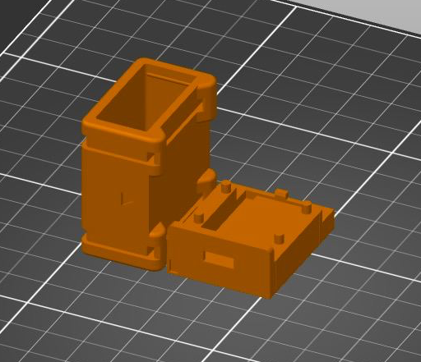

To achieve a perfect print result, the parts to be printed should be arranged as seen in Figure 2.

If you use a *Prusa i3 MK3* printer, you will find the print-ready files in the 3D print folder. For any other printers you have to convert the .STL- files into the corresponding printer format.

### **Step 3:** Check if the Arduino and the sensor fit into the case

**Caution!** Before working with electrical components, make sure that you are not electrostatically charged. Touch either the metal of a tap or heater before touching any electrical components!

After printing, check if the Arduino and the sensor fit nicely into the case. Figure 3 shows the assembled headtracker.

The Arduino Pro Micro has to be placed with its flat side on the bottom of the drawer and the sensor mounted on the four cylinders above the Arduino. The sensor should fit perfectly on the four provided mounting pins.

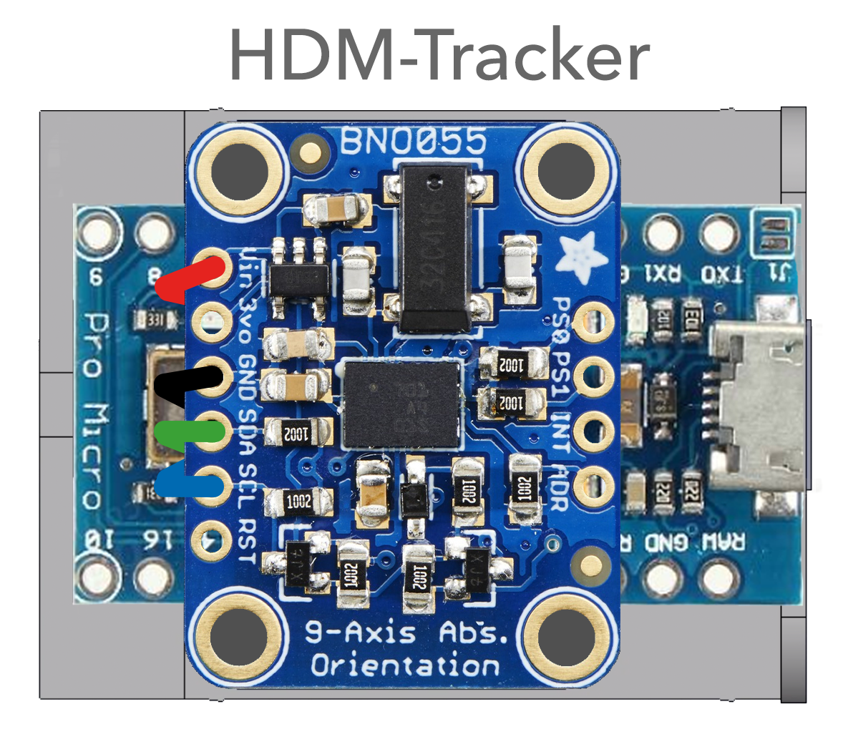



### **Step 4:** Cut and dismantle jumper wires

Jumper wires are used to connect the sensor to the Arduino. In order to fit correctly into the case, each wire should have a length of roughly 30 millimeters. Dismantle approximately 3 millimeters on each end.

### **Step 5:** Connect the sensor to the Arduino

A third-hand tool helps you to clamp the components during soldering. Tin the stripped wires with solder. Solder the IMU sensor (BNO055) to the Arduino Pro Micro according to the [circuit diagram](https://www.dict.cc/englisch-deutsch/circuit+diagram.html), below (*Figure 4*). For instructions on how to solder correctly, follow the links below:

[**Soldering example**](https://cdn-learn.adafruit.com/downloads/pdf/adafruit-guide-excellent-soldering.pdf) **(English) /** [**Richtig löten**](https://eckstein-shop.de/docs/L%C3%B6tanleitung.pdf) **(German)**

**Notice!** The cables should run between the Arduino board and the sensor. Make sure that you do not use too much solder on the soldering points, otherwise it might not fit correctly into the case.

**Tip:** Use the color-coding shown below (*Figure 4*) to avoid confusion.

* Connect the power input of the sensor (**Vin**)

to the Arduino’s power supply (**VCC**)

* Connect **GND** to common power/data ground  **GND**
* Connect the **SDA** pin of the sensor to the I2C data SDA pin on your Arduino (**digital 2**)
* Connect the **SCL** pin to the I2C clock SCL pin on your Arduino (**digital 3**)

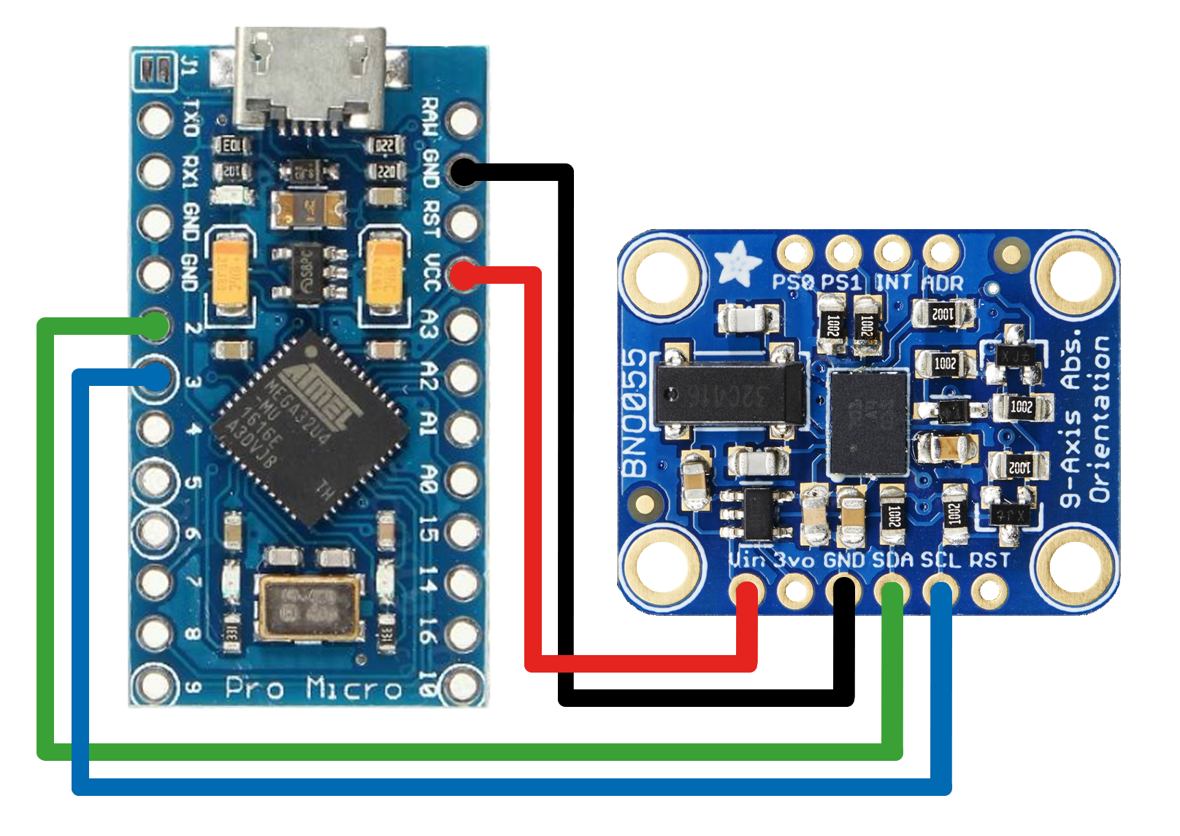



### **Step 6:** Mount the electronic components to the drawer.

The Arduino and the sensor fit into the drawer as shown in *Figure 3*.

**Notice!** Before closing the case, it is important to perform a functional test. For that reason, we continue with the implementation of the software before we put the drawer in the case and close it.

Once the assembly is complete, we will continue with the installation of the device software.

## 

## **Device software:**

### **Step 7:** Download andInstall Arduino IDE software:

Under the following link you will find the download of the Arduino software:

<https://www.arduino.cc/en/Main/Software>

Download the software and follow the instructions given by the installer program.

If you have never used the Arduino before, you will find examples to test the features of the Arduino under the following link:

<https://learn.sparkfun.com/tutorials/pro-micro--fio-v3-hookup-guide#example-1-blinkies>

This website also provides you with a tutorial, which shows you how to use the Arduino on Windows or Mac.

**Tip:** Copy *Example1: Blinkies!* and upload it to the Arduino Pro Micro to test the basic functionality.

### **Step 8:** Download and install the required Arduino libraries

**Notice!** The library should only be downloaded from the Arduino library manager.

Libraries should not be stored separately on your computer.

Open Arduino IDE’s library manager (*Figure 5*).

**Step 8.1:** If you are using an Arduino IDE version prior to 10.8., search for the “Adafruit Sensor library“ and install it. For newer releases of the software, this action is not required.

**Step 8.2:** However in any case you have to search and install “Adafruit BNO055 Library for Absolute Orientation Sensor”.

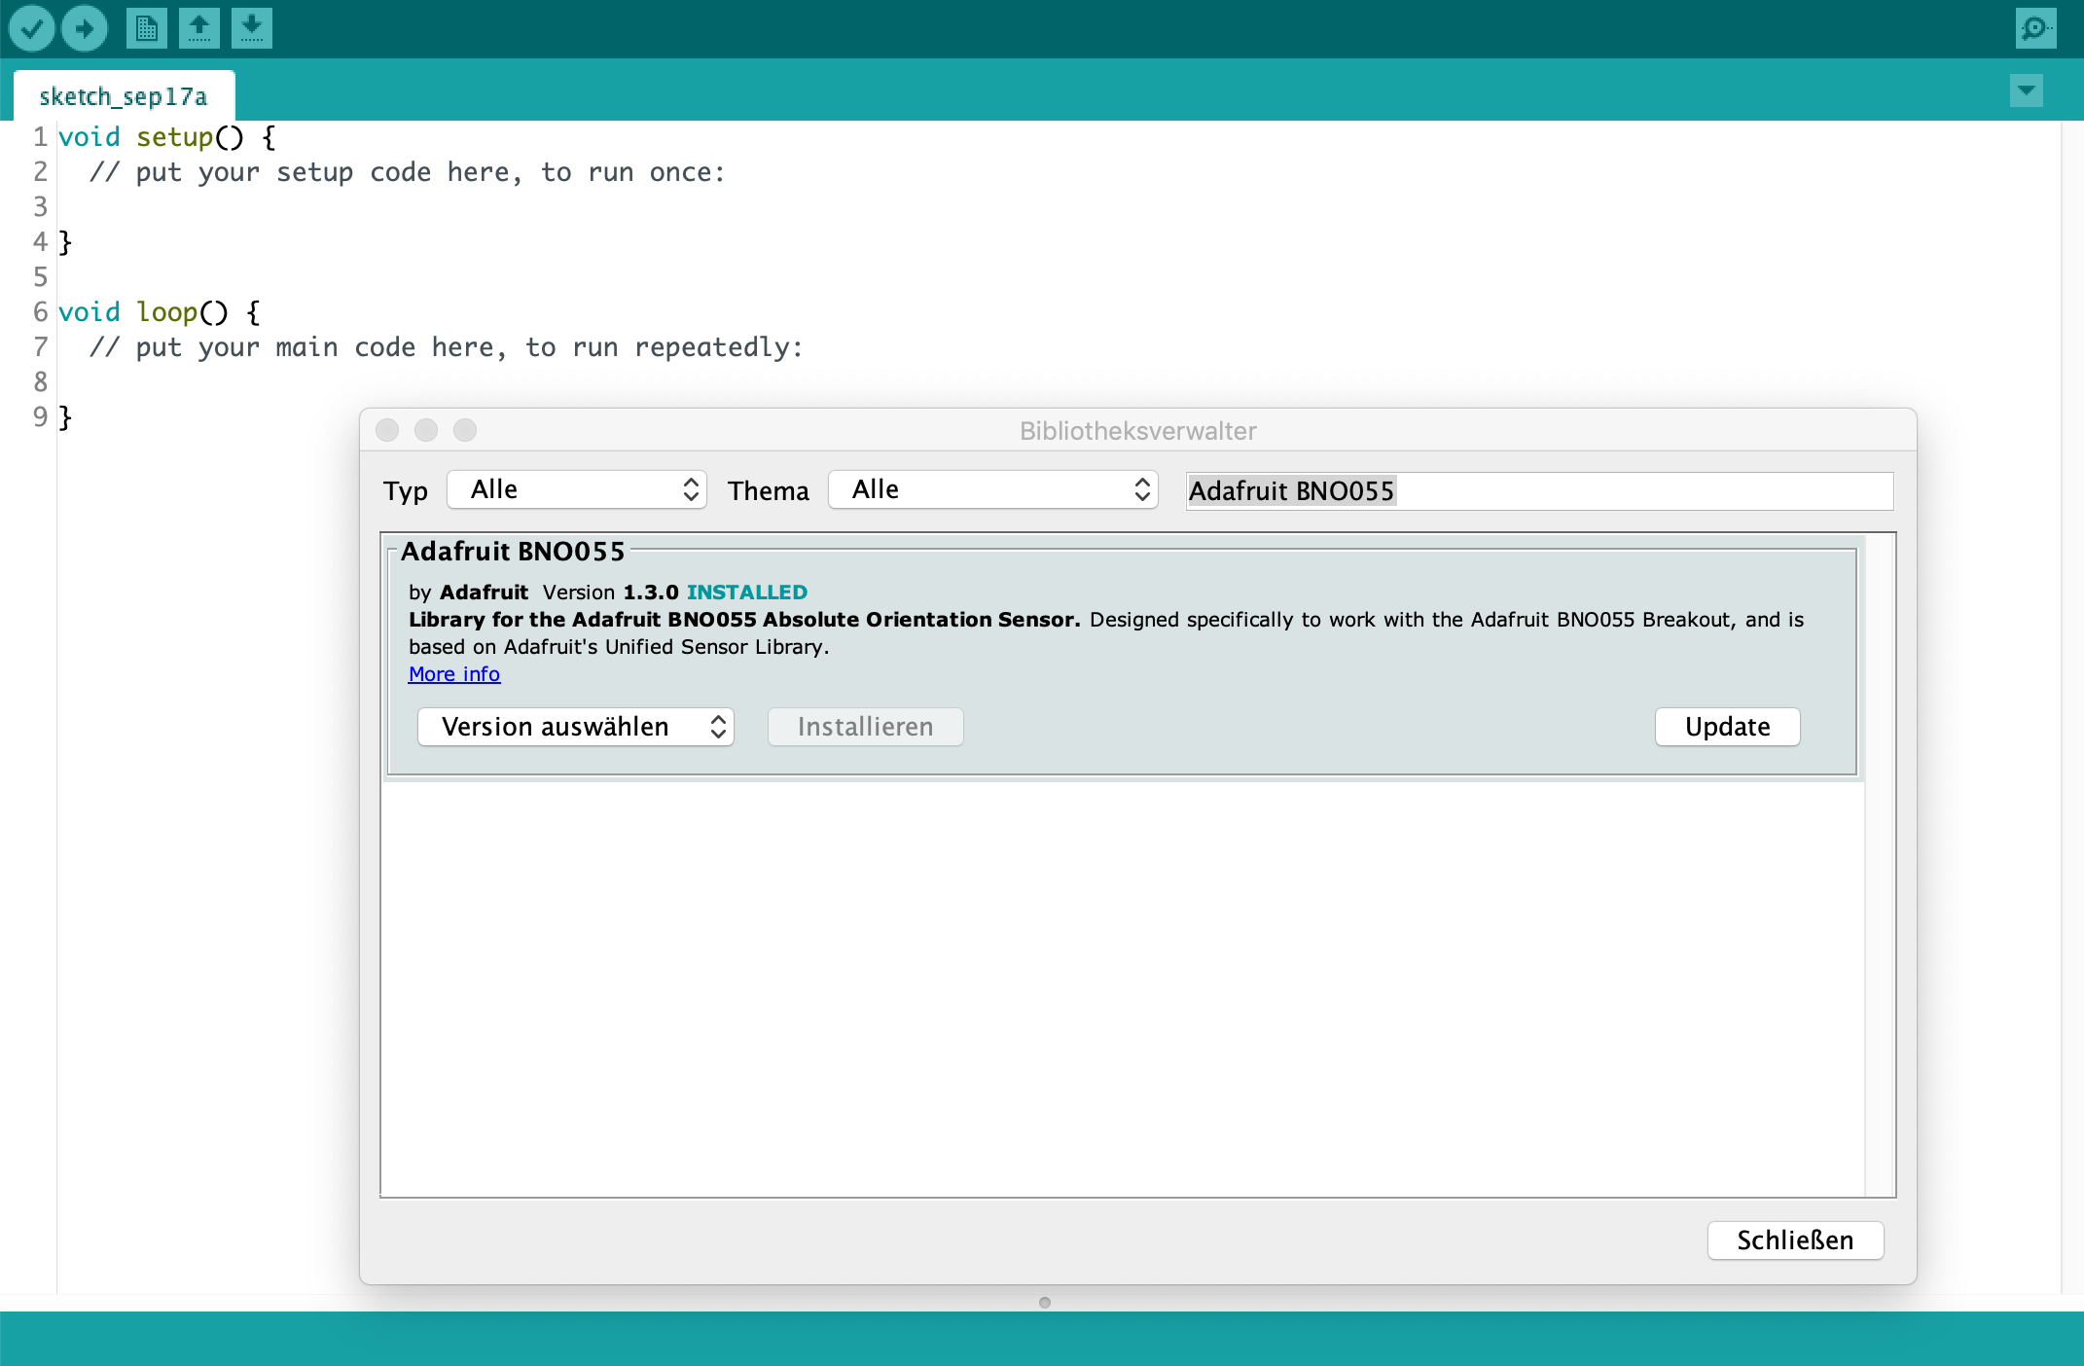



A tutorial on Arduino library installation can be found under the following link:

<https://learn.adafruit.com/adafruit-all-about-arduino-libraries-install-use>

### **Step 9:** Programming the Arduino

**Step 9.1:** Connect the HdM-Tracker to your computer with the Micro-USB cable.

**Step 9.2:** Open the Arduino sketch “headtracker_Micro_BNO055” inArduino IDE. You will find the sketch under:

HdM_Tracker-master/Arduino/headtracker_Micro_BNO055

**Step 9.3:** To program the Arduino Pro Micro, choose the Board “Arduino Leonardo” in the tools section (*Figure 6*).

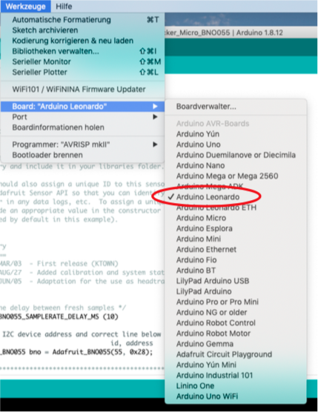



**Step 9.4:** Choose the belonging Port “(Arduino Leonardo)” in the tools section (*Figure 7*).

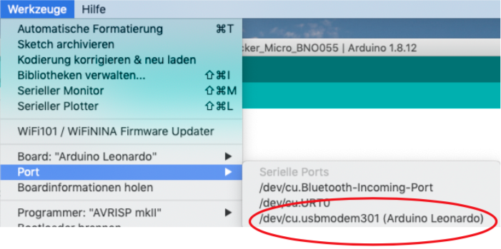



**Step 9.5:** Check and upload the sketch to your device. Once the sketch is successfully uploaded, two red LEDs will flash on the Arduino board.

Once the setup process is complete and any functional tests are successful, we go on with assembling the hardware.

## **Hardware (Part 2):**

### **Step 10 (optional):** Attach the sensor to the drawer

If you want to make sure that everything works perfectly, you should attach the sensor to the drawer. If you made sure that everything works correctly and you don't need to touch up or change anything on the board in the future, you can melt the four fixing pins above the Arduino with a hot object to attach the sensor to the drawer.

Melt the four fixing pins above the Ardunio with a hot object, for example the tip of a flat screwdriver, which was heat up with a flame. Press the tip with the flat side onto the four fixing pins (*Figure 8*).

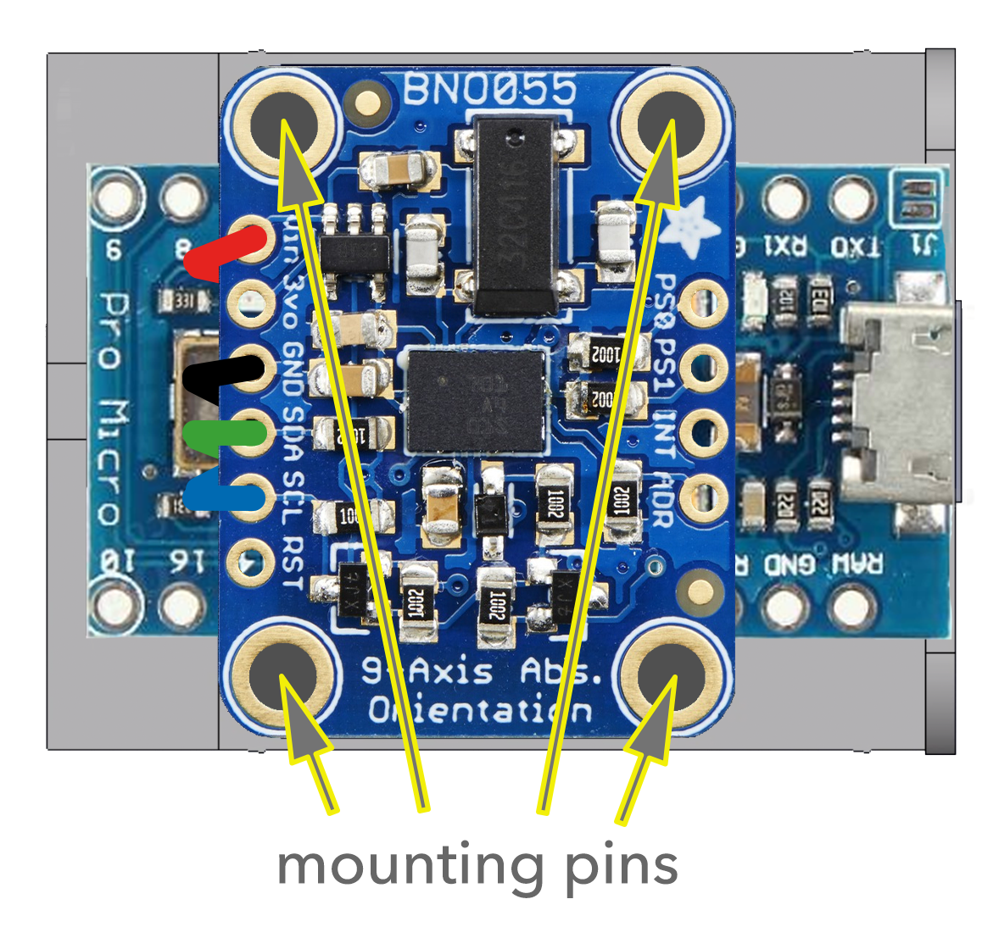



For a perfect fit the cables should run between the Arduino board and the sensor. If you don't want to do this because you want to be able to change something, we can say that the sensor is also well placed inside the case.

### **Step 11:** Insert the drawer into the case

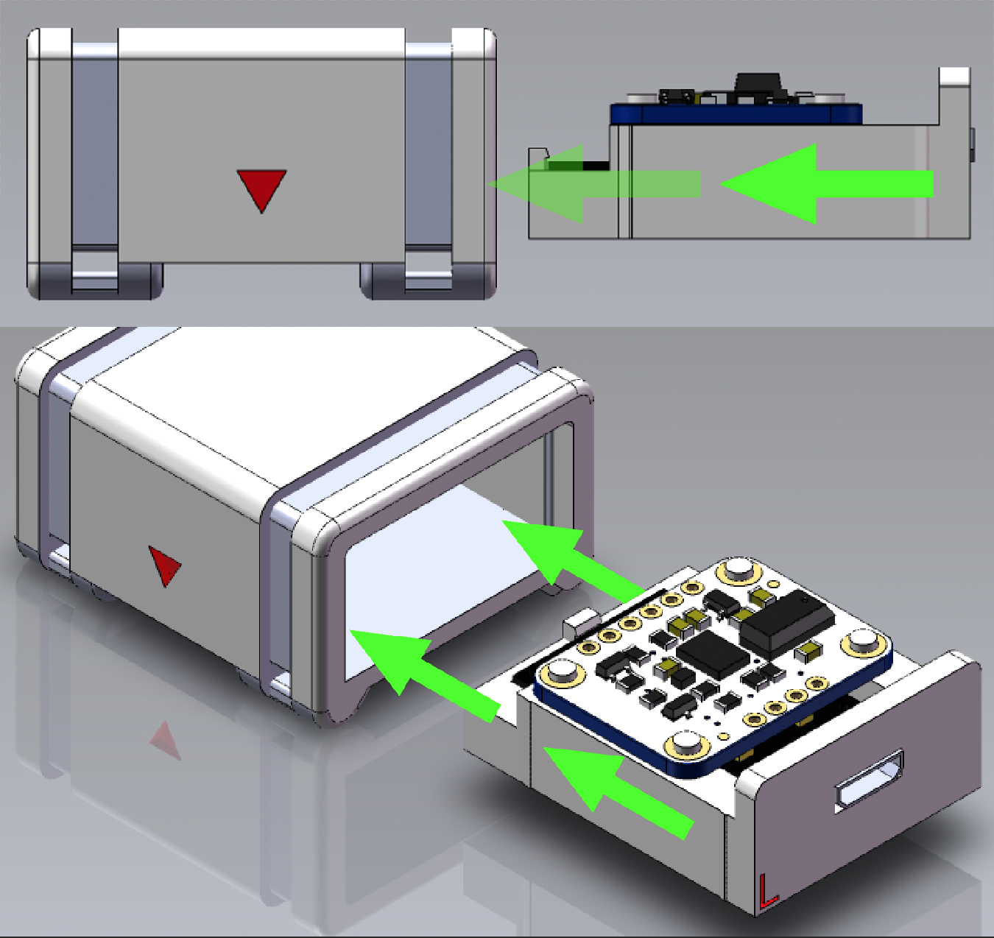

Slide the drawer into the housing until you hear a click (*Figure 9*). The drawer is then firmly secured.

If you want to remove the drawer from the case, you will find an opening on the opposite side of the USB-port. Take a suitable tool, such as an M3 Allen key or similar, and push it strongly into the opening. This should open the drawer.

### **Step 12:** Mount the HdM-Tracker onto your headphones

Please make sure that the headtracker is correctly attached to your headphones.

The opening of the USB connector has to be located to the left side of the headphones (*Figure 10*)*,* so that the USB cable can be connected to the headphone cable in some cases.

Pull the cable ties through the holes provided in the feet of the headtracker and adjust them around the headphones bracket.

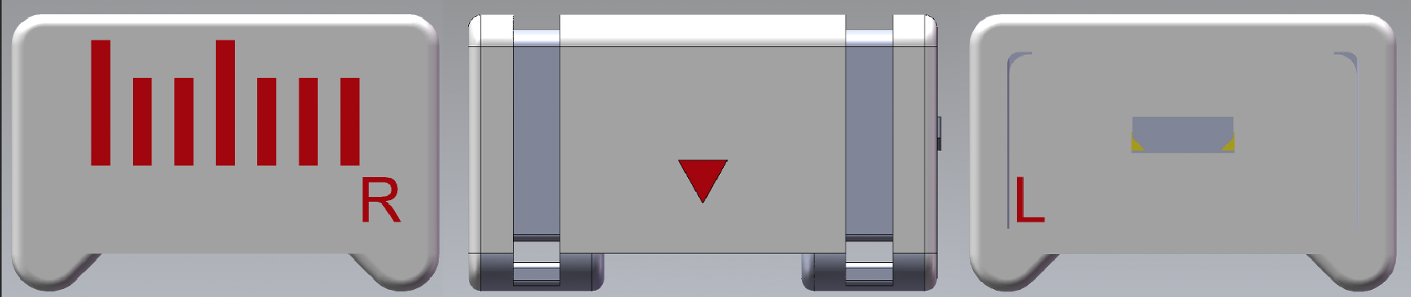



**Notice!** Before you tighten the cable ties, make sure the little arrow in the middle of the case sits directly in the middle of your headphone bracket (*Figure 11*). If this is not the case, the tracking might be offset.

After that you should be able to tighten the cable ties.

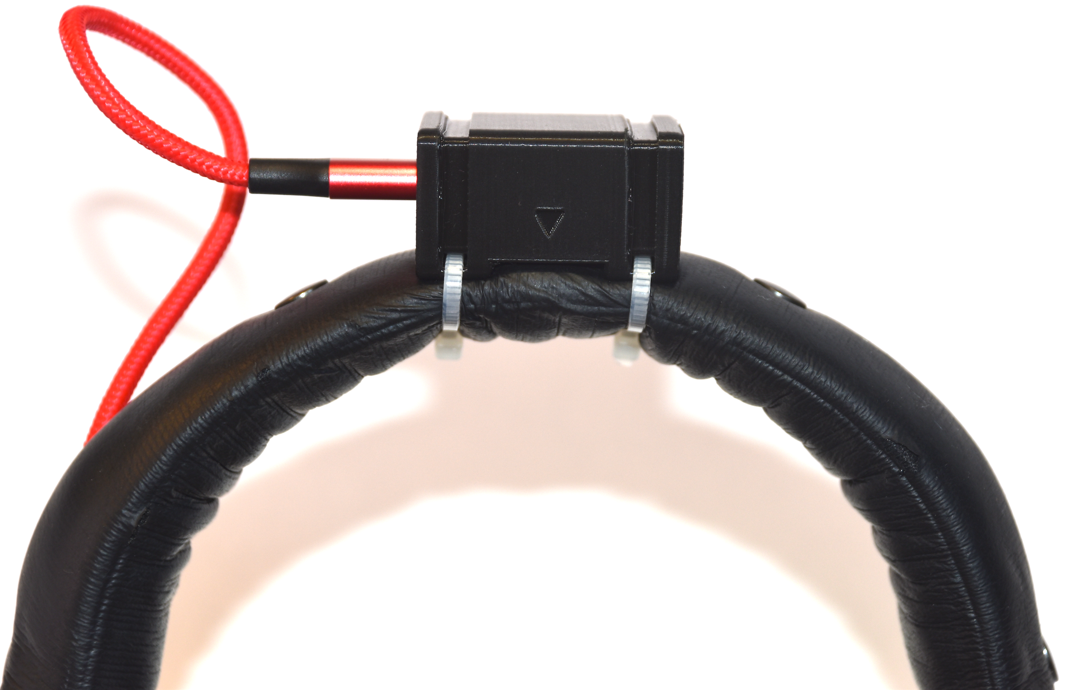



### **Step 13:** Attach the USB cable to your headphone cable

To avoid disturbances, the USB cable should be tightly attached to your headphone cable. You can fasten the USB cable onto your headphone and headphone cable by using cable ties or shrink tubes (*Figure 12)*. The diameter depends on the used headphones. For the cable of the Beyerdynamic DT-770/DT-990 the shrink tube should have a diameter of Ø17mm and when tightened the diameter should be about Ø5mm.

To protect the head trackers USB port, a strain relief should be provided.

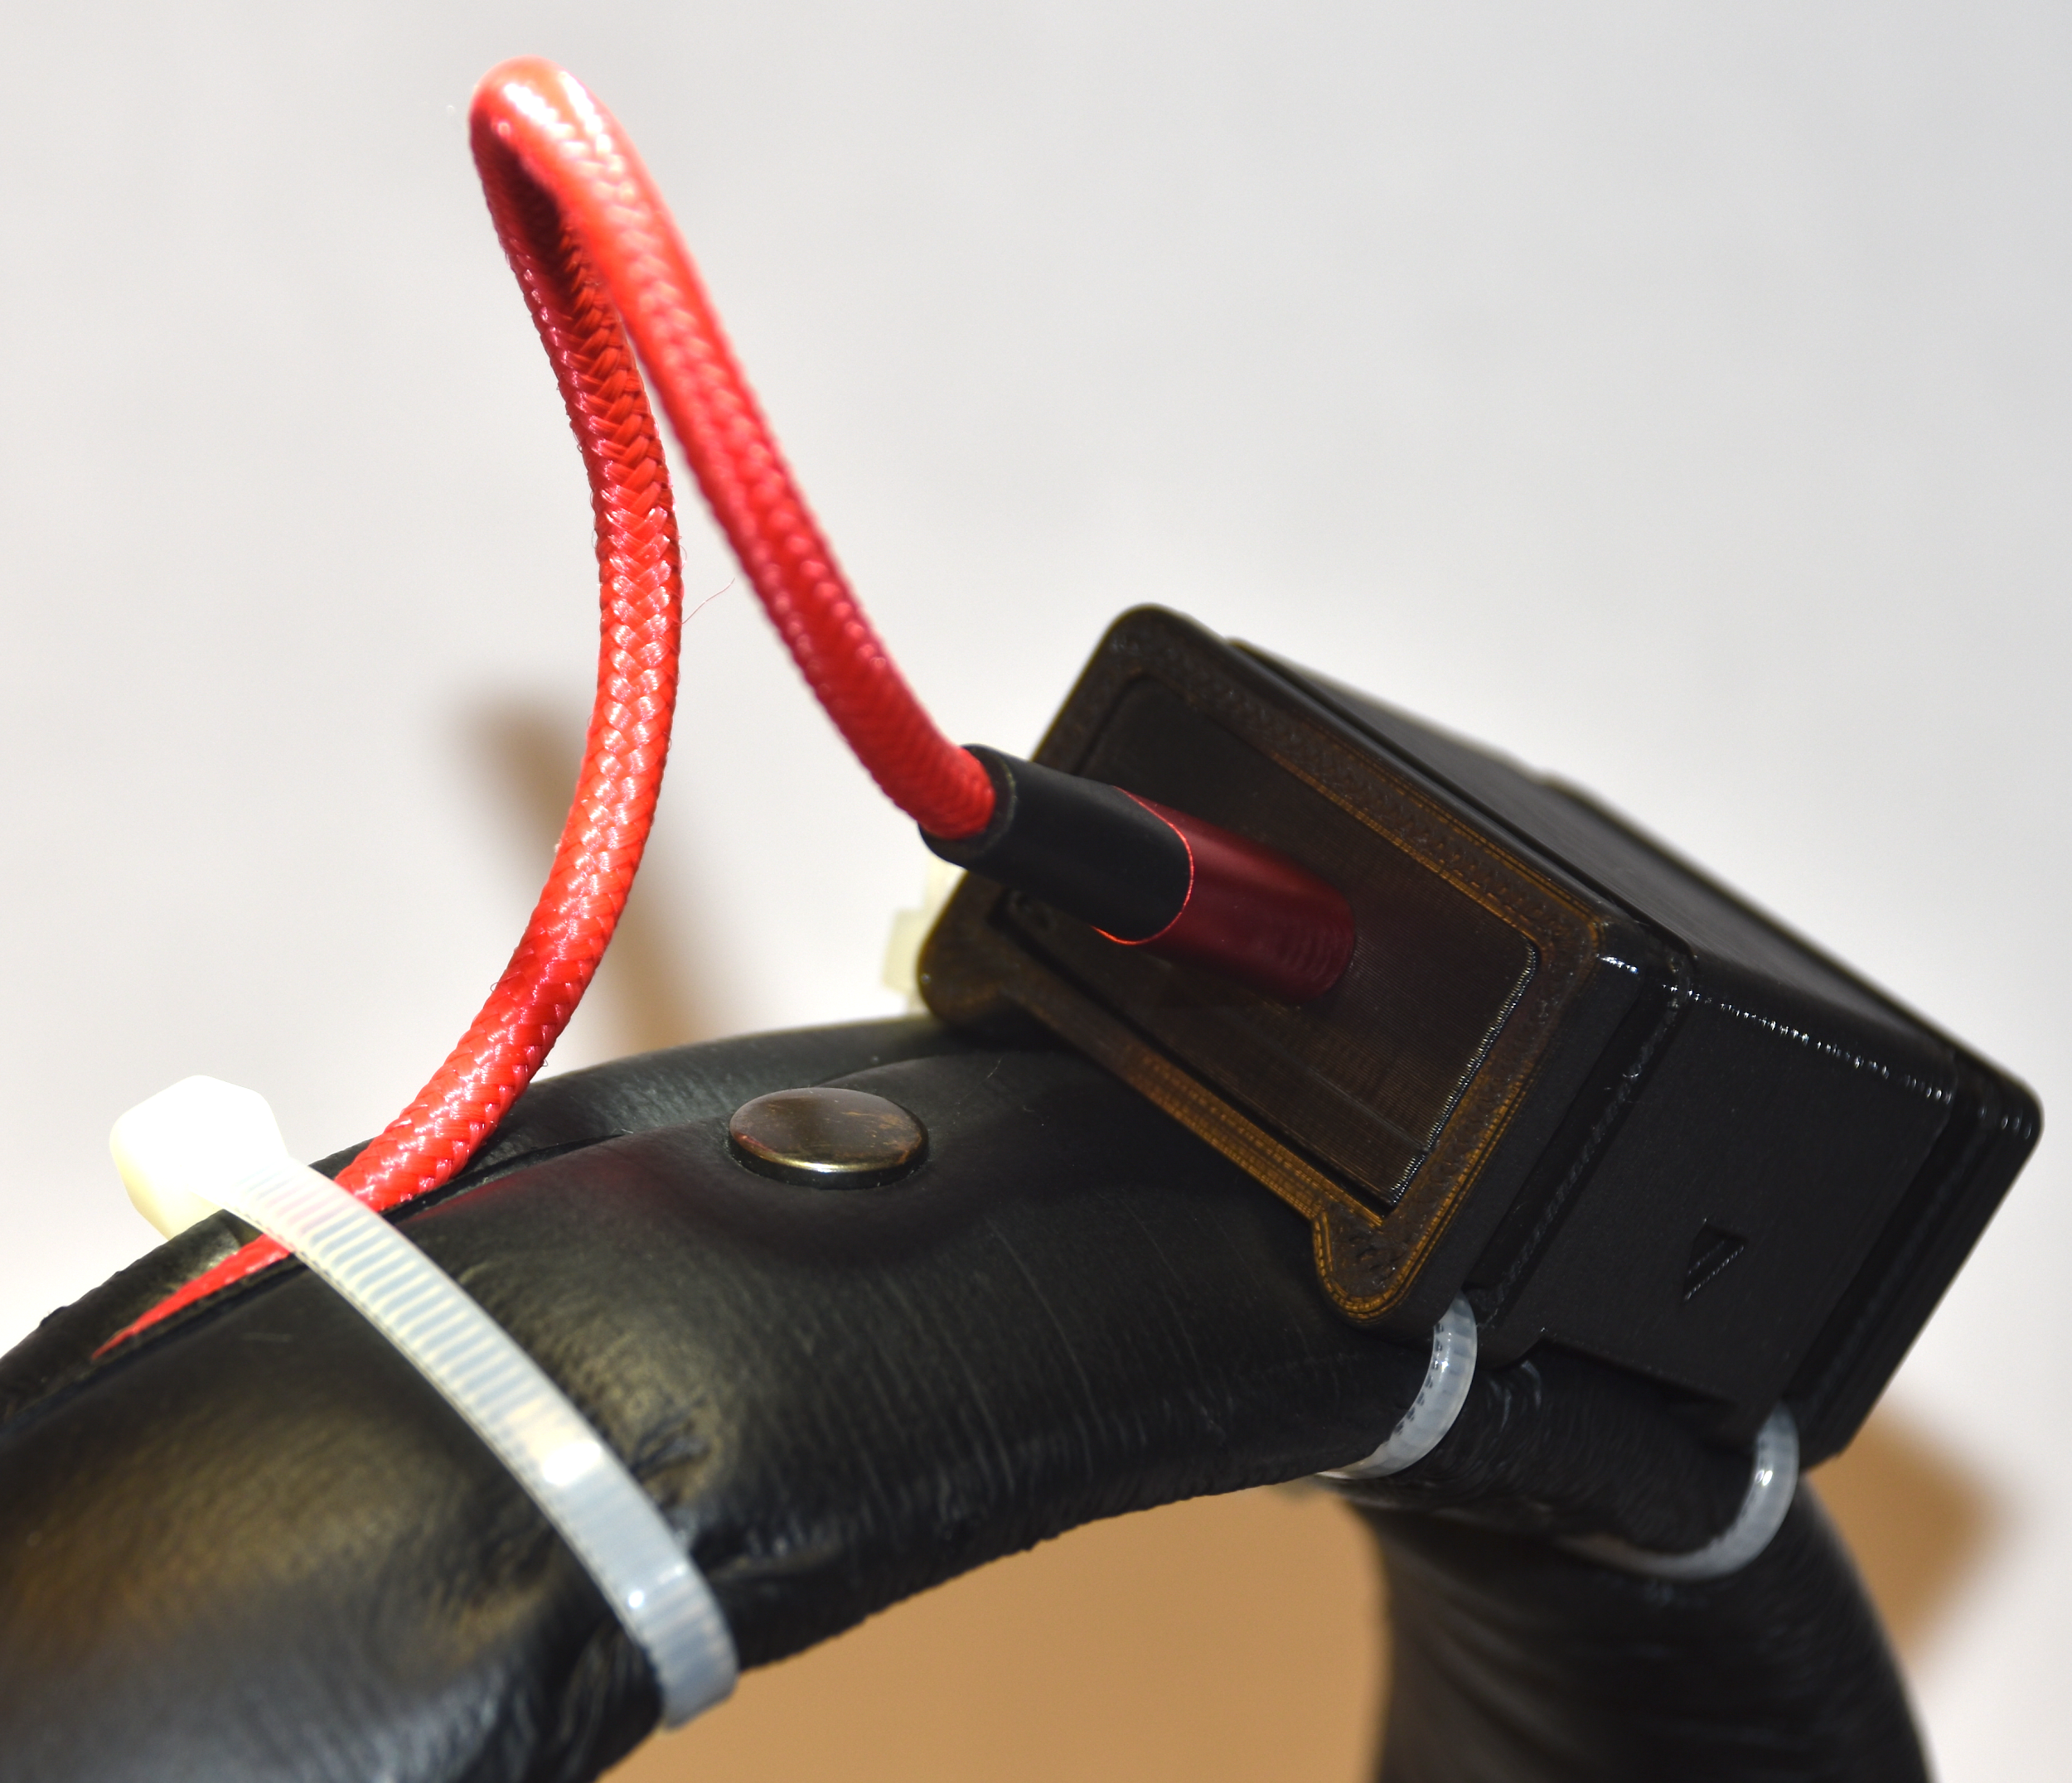



**Tip:** If your headphones have a spiral cable, place the USB-cable in the center, which is where it least disturbs (*Figure.13*).

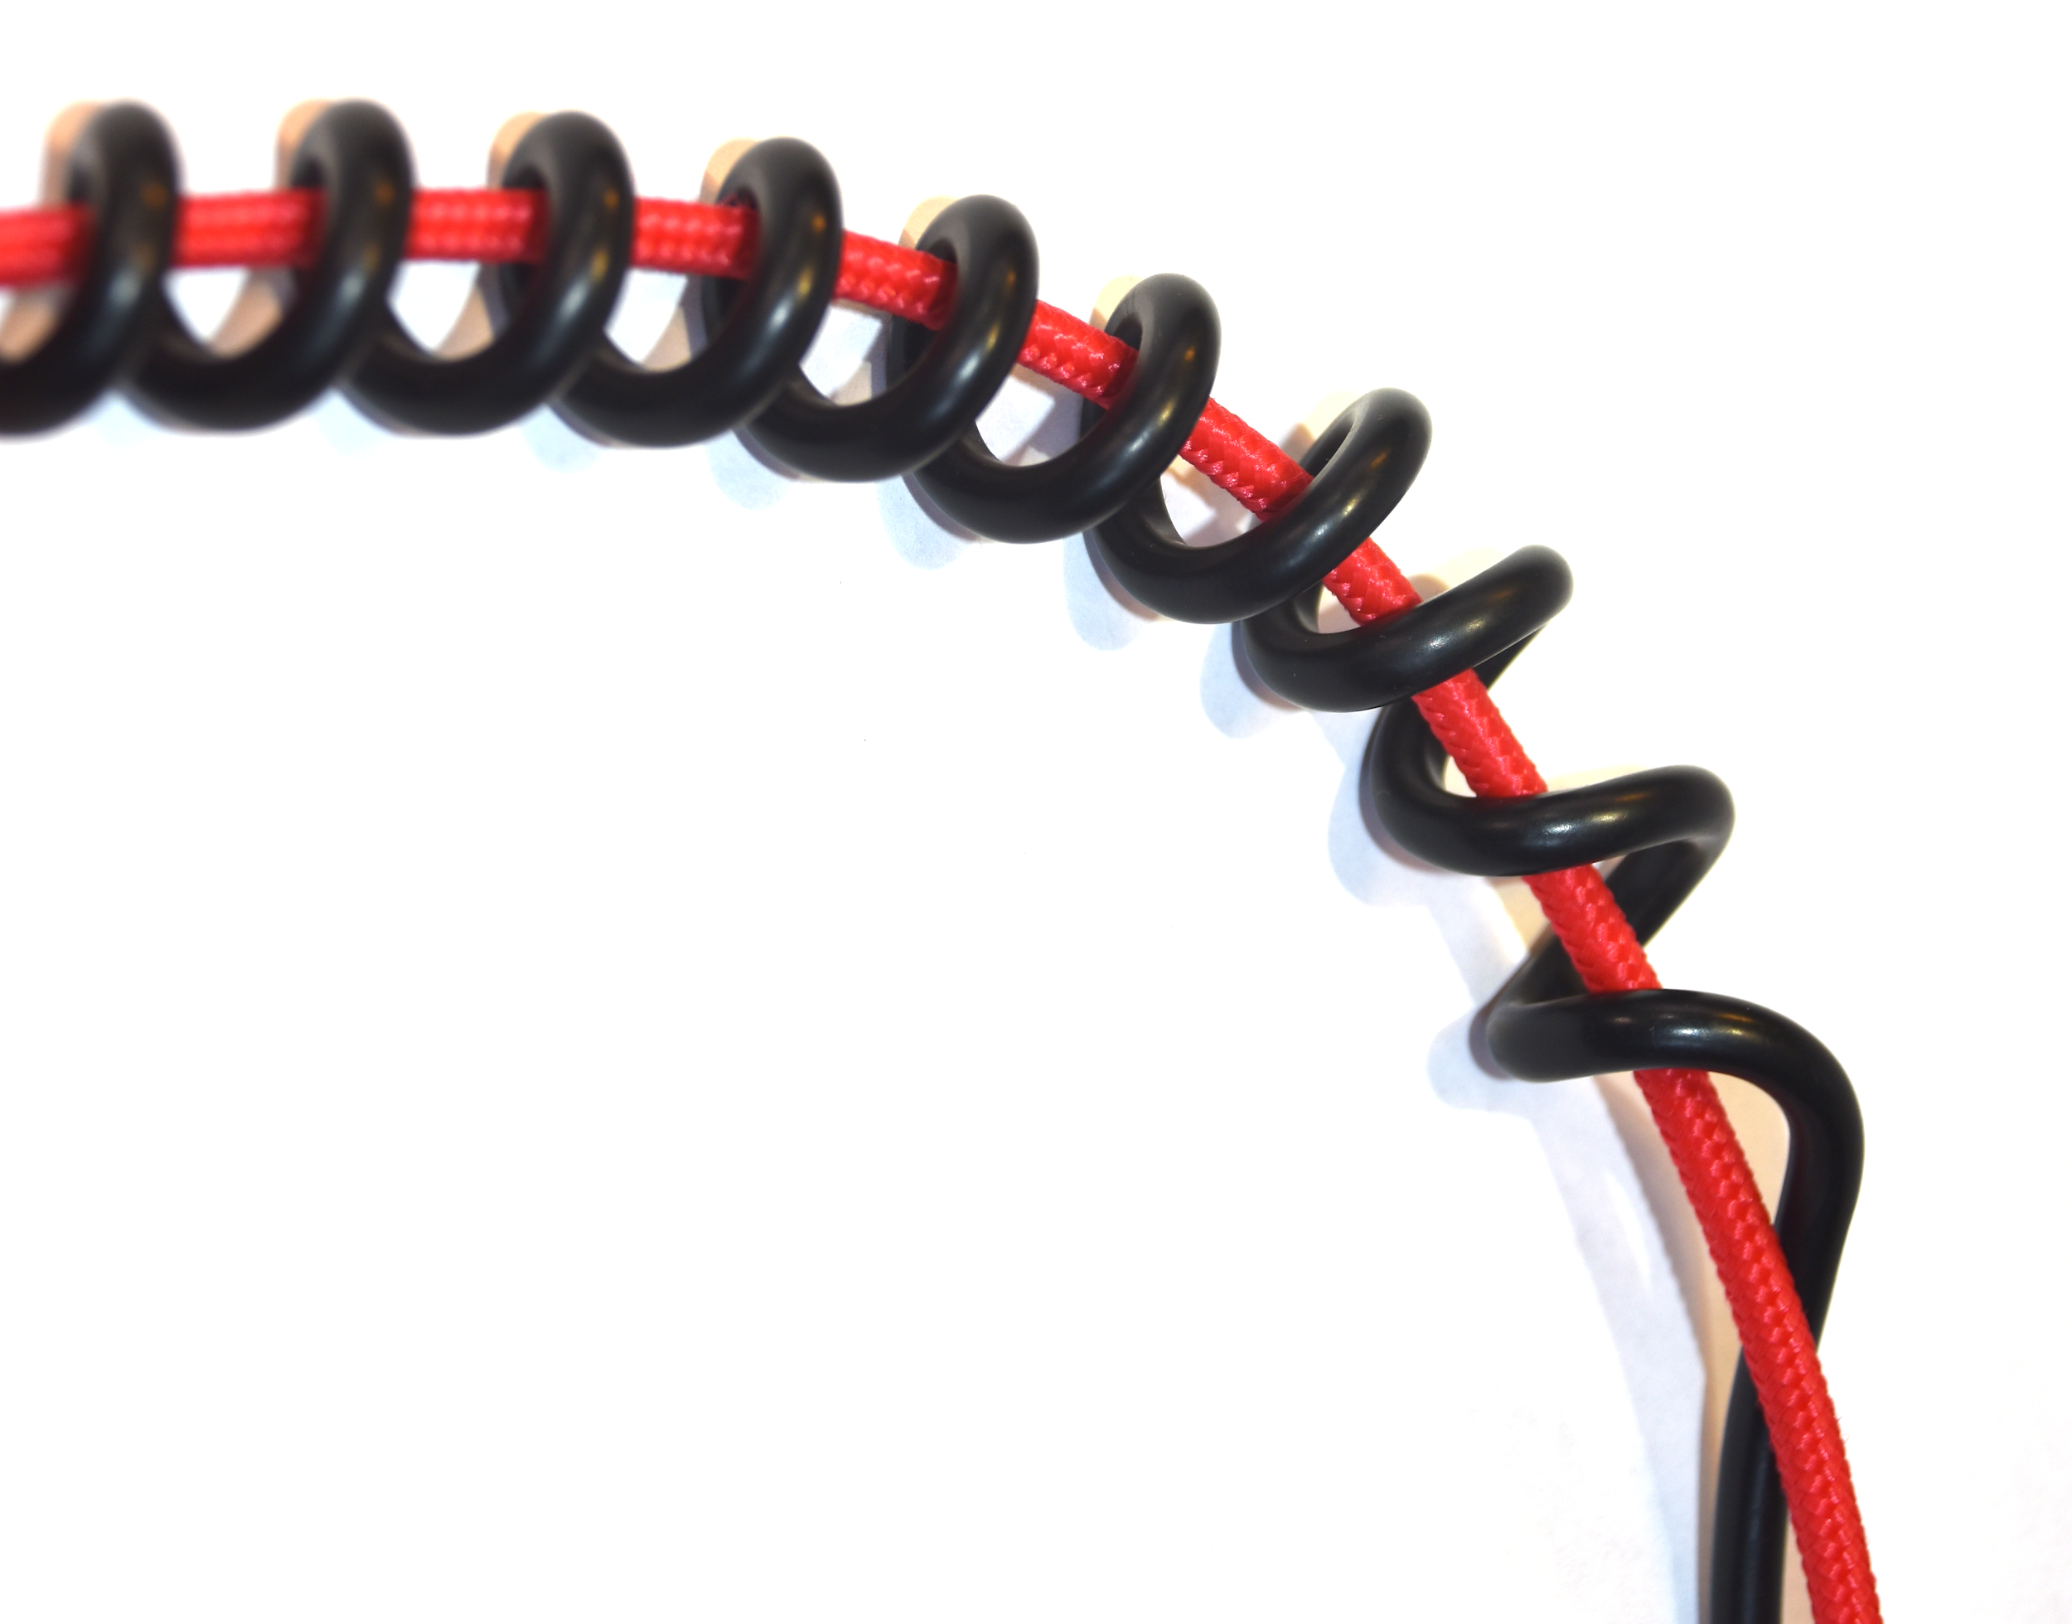



# 

# Software instruction manual:

## **Software to apply the Headtracker:**

For the description click here or read more starting from page 21.

# 

# **Version 2:** The headtracker in a heat shrink tube

# Required Components

### Hardware:

1) **Arduino Pro Micro board** 5V/16MHz with ATmega32U4

2) **Adafruit BNO055 -** 9DOF sensor (IMU-Sensor)

3) **HdM-Tracker circuit board**

4) **Cable tie**

5) **6- pin headers** plus one **single pin header**

6) **Micro-USB cable** ca. 2m / 6,56 ft

7) **Mouldable Glue like Sugru/Tesa or comparable product**

8) **Heat shrink tube** Ø ca.17mm / 0,67 inches

|  |  |  |  |
| --- | --- | --- | --- |
| 1 | 2 | 3 | 4 |
| 5 | 6 | 7 | 8 |

### 

### Software:

• [**Arduino IDE**](https://www.arduino.cc/en/main/software) with the following libraries:

· **Adafruit BNO055** library

· **Adafruit Sensor** library (only for releases prior to version 10.8.)

• [**Max/MSP**](https://cycling74.com/get-started) **(https://cycling74.com/get-started)**

• [**OSC-Bridge**](https://github.com/trsonic/nvsonic-head-tracker) **(https://github.com/trsonic/nvsonic-head-tracker)**

**(https://wp.nyu.edu/immersiveaudiogroup/2018/01/26/nvsonic-headtracker-nyu/)**

### Additional Tools:

• **Soldering equipment** (Soldering Iron, solder and desoldering strand)

• Third-hand Tool

• Blow dryer

# 

# Building instructions Version 2:

### **Step 1:** Download the Github repository

Under the following link you will find all required files for the construction and operation of the HdM-Tracker:

<https://github.com/melchior-hdm/HdM_Tracker>

When clicking on the button “Code” a drop-down menu will appear. Click on “Download ZIP” to download the repository to your computer. When the download is finished, unzip the folder and store it on your computer.

## **Hardware (Part 1):**

### **Step 2:** Solder the pin headers to the top and the bottom of the circuit board

**Notice!** The single pin is for stability reasons only. It’s free end has to be cut right above the plastic coating.(*Figure 15*)



### **Step 3:** Solder the Arduino to the pin headers on the top of the circuit board

The board is labeled so you can easily see where the Arduino and BNO055 have to be soldered.

**Notice!** The top of the Arduino, where the USB socket is located, is facing the circuit board.

Make sure to cut off the loose ends of the pinheads afterwards.

### **Step 4:** Solder the sensor to the six pin headers on the bottom of the circuit board

**Notice!** The sensor must be mounted upside down, the components must face the circuit board (*Figure 16*). The six pins must be soldered in this position,

otherwise the alignment will be shifted and the connections will not match correctly.

Make sure to cut off the loose ends of the pinheads afterwards.

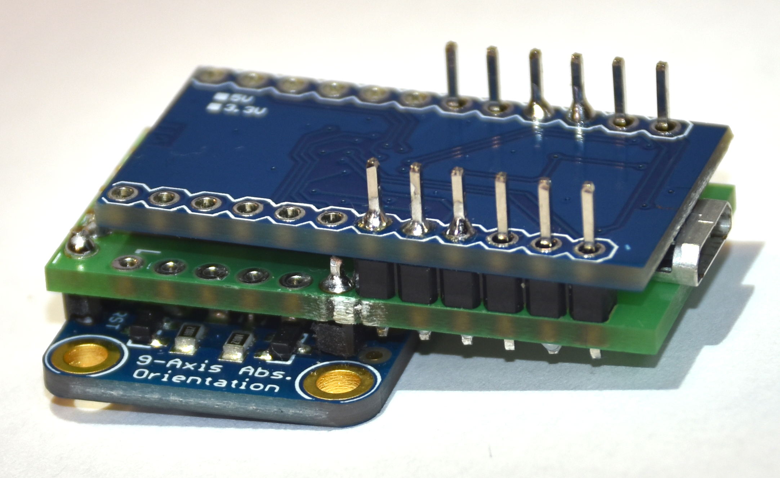



Once the assembling process is complete we go on with setting up the device software.

## **Device software:**

### **Step 5:** Download andInstall Arduino IDE software:

Under the following link you will find the download of the Arduino software:

<https://www.arduino.cc/en/Main/Software>

Download the software and follow the instructions given by the installer program.

If you have never used the Arduino before, you will find examples to test the features of the Arduino under the following link:

<https://learn.sparkfun.com/tutorials/pro-micro--fio-v3-hookup-guide#example-1-blinkies>

This website also provides you with a tutorial, which shows you how to use the Arduino on Windows or Mac.

**Tip:** Copy Example1: Blinkies! and upload it to the Arduino Pro Micro to test the basic functionality.

### **Step 6:** Download and install the required Arduino libraries

**Notice!** The library should only be downloaded from the Arduino library manager.

Libraries should not be stored separately on your computer.

Open Arduino IDE’s library manager *(Figure 5)*.

**Step 6.1:** If you are using an Arduino IDE version prior to 10.8., search for the “Adafruit Sensor library“ and install it. For newer releases of the software, this action is not required.

**Step 6.2:** However in any case you have to search and install “Adafruit BNO055 Library for Absolute Orientation Sensor”.





A tutorial on Arduino library installation can be found under the following link:

<https://learn.adafruit.com/adafruit-all-about-arduino-libraries-install-use>

### **Step 7:** Programming the Arduino

**Step 7.1:** Connect the HdM-Tracker to your computer with the Micro-USB cable.

**Step 7.2:** Open the Arduino sketch “headtracker_Micro_BNO055” inArduino IDE. You will find the sketch under:

HdM_Tracker-master/Arduino/headtracker_Micro_BNO055

**Step 7.3:** To program the Arduino Pro Micro, choose the Board “Arduino Leonardo” (*Figure 18*) in the tools section.





**Step 7.4:** Choose the belonging Port “(Arduino Leonardo)” *(Figure 19)* in the tools section.





**Step 7.5:** Check and upload the sketch to your device. Once the sketch is successfully uploaded, two red LEDs will flash on the Arduino board.

Once the setup process is complete and any functional tests are successful, we go on with assembling the hardware.

## **Hardware (Part 2):**

### **Step 8:** Model a flat bottom surface

Use Tesa Suguru or a similar moldable glue to adjust the height of both elements *(Figure 20)*.

**Notice!** If the sensor does not sit flat on top of your headphones brackets the orientation will be offset.

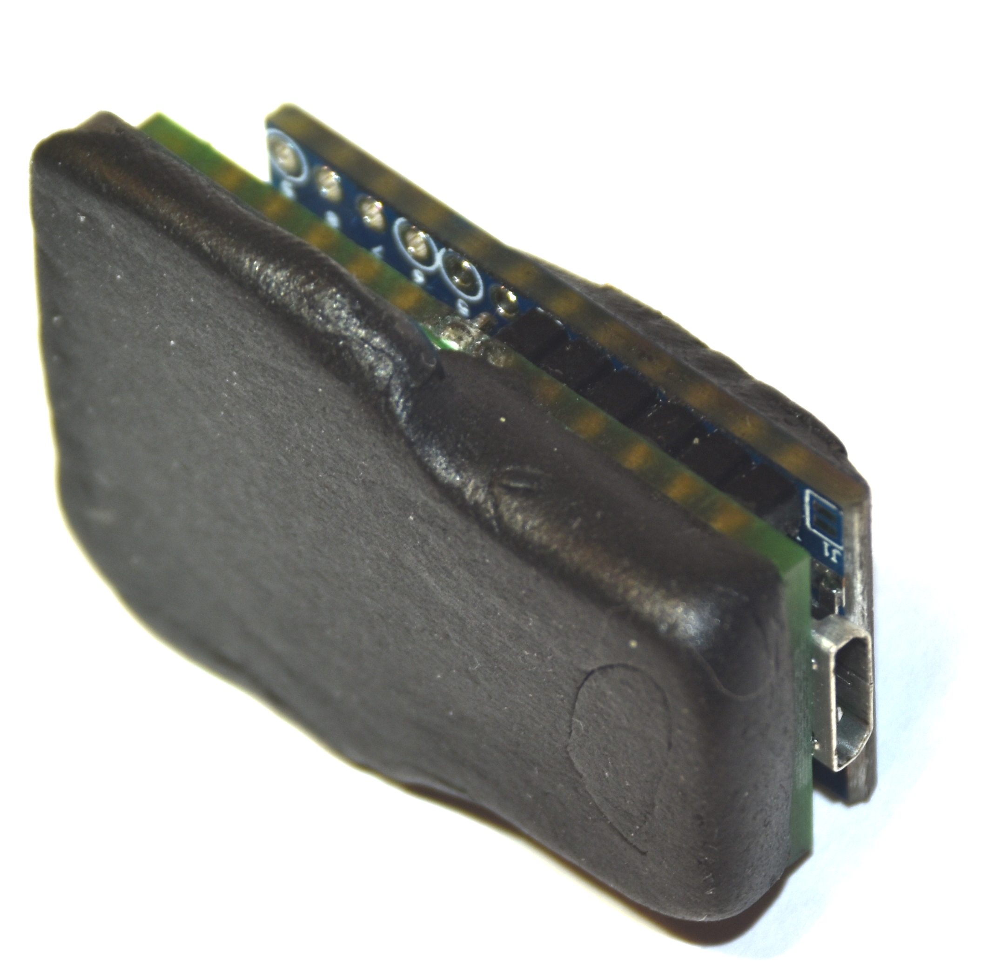



### **Step 9:** Plug in the USB cable and place everything in the heat shrink tube

### **Step 10:** Shrink the tube with a blow dryer

Cut four small holes in the heat shrink tubing before it is completely shrunk. Put two cable ties through them and then shrink the tube to its final size.

### **Step 11:** Attach the headtracker to your headphone brackets

To do so, use the two cable ties.

**Notice!** Make sure to place it in the middle of the brackets. Otherwise the orientation will be offset (*Figure 21*).

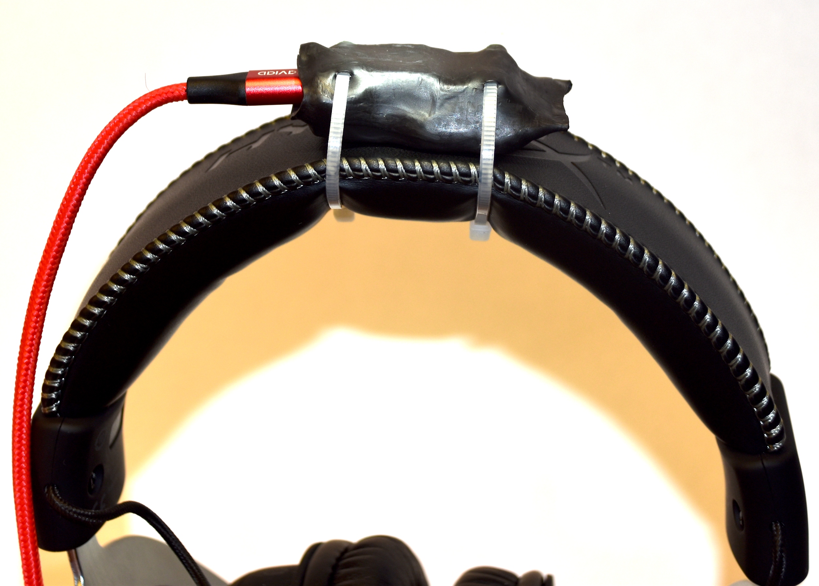



# Software instruction manual

## **Software to apply the Headtracker:**

### **Step 1:** Installation of the operating software with Max/MSP and spat5

**Step 1.1**:Download the Software Max/MSP in trial condition

•  [**Max/MSP**](https://cycling74.com/get-started) **(**[**https://cycling74.com/get-started**](https://cycling74.com/get-started)**)**

**Step 1.2**: Download and install the software suite spat5 for Max/MSP

•  [**Spat 5**](https://forum.ircam.fr/projects/detail/spat/) **(**[**https://forum.ircam.fr/projects/detail/spat/**](https://forum.ircam.fr/projects/detail/spat/)**)**

**Step 1.3**: Open [HdM_Tracker](https://github.com/melchior-hdm/HdM_Tracker) on GitHub

Open the MAX folder under the HdM_Tracker on GitHub and download the headtrackerReceiver patch to use the HdM-Tracker.

You can find the folder under the following path:

[HdM_Tracker-master/MAX/..](https://github.com/melchior-hdm/HdM_Tracker)

• [**headtrackerReceiver**](https://github.com/melchior-hdm/HdM_Tracker/tree/master/MAX)

**(https://github.com/melchior-hdm/HdM_Tracker/tree/master/MAX)**

### **Step 2:** Setting up the MAX-Patch

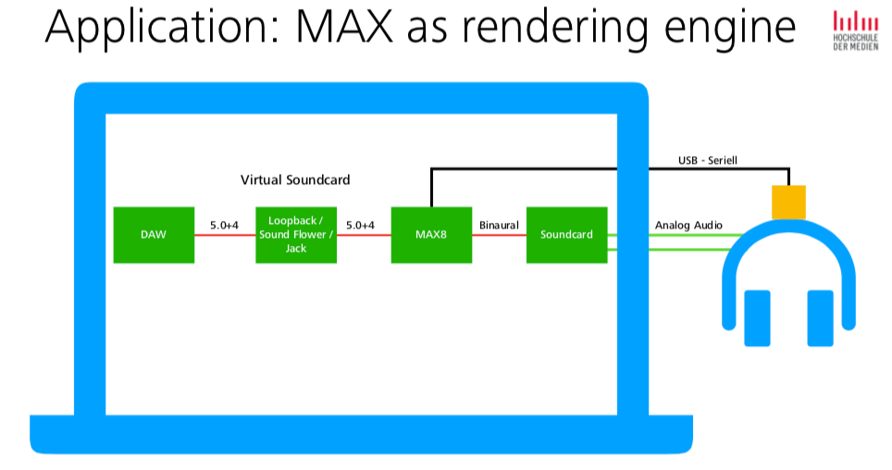

**Step 2.1**: Open the sample patch to connect the HdM-Headtracker correctly to the software.

**Tip:** To make working with this MAX8 patch easier, it is recommended to maximize the window (*Figure 22*).

**Step 2.2:** Use the print message in Max/MSP to find the correct port address. The available ports are then shown in the Max Console.

**Step 2.3:** Adjust port message if needed. To change the port it is necessary to unlock the patch in the bottom left corner.

**Step 2.4:** Open port using the open message.

**Step 2.5:** Enable head-tracking in the patch.

**Step 2.6:** Use the reset button to set the correct head orientation.

**Tip:** After some time it is not wrong to align the head correctly and straight and then press the reset button. Your work situation is then brought back into the correct position again.

### **Step 3:** Setting up the OSC-Bridge *(Figure 23)*



**Step 3.1:** Under the following link you can download the OSC Bridge and read a full installation guide for:

<https://github.com/trsonic/nvsonic-head-tracker>

**Step 3.2:** Install the application

**Step 3.3:** Connect to HdM-Tracker

**Step 3.4:** Select port from the Port List after hitting the refresh button

**Step 3.5:** Enable OSC link receiver in the plug-ins

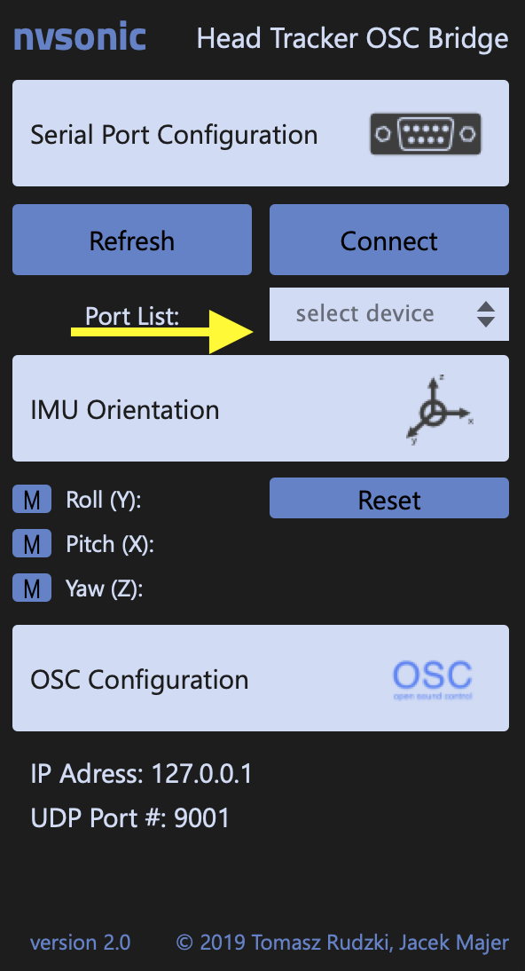



### **Step 4:** Setting up the OSC-Receiver in the iem-Plugins

• [**Scenerotator**](https://plugins.iem.at/)from the IEM Plug-in Suite **(**[**https://plugins.iem.at/**](https://plugins.iem.at/)**)**

**Step 4.1:** Click on OSC in the bottom left corner (Figure 25)

**Step 4.2:** Enter the correct IP address and port

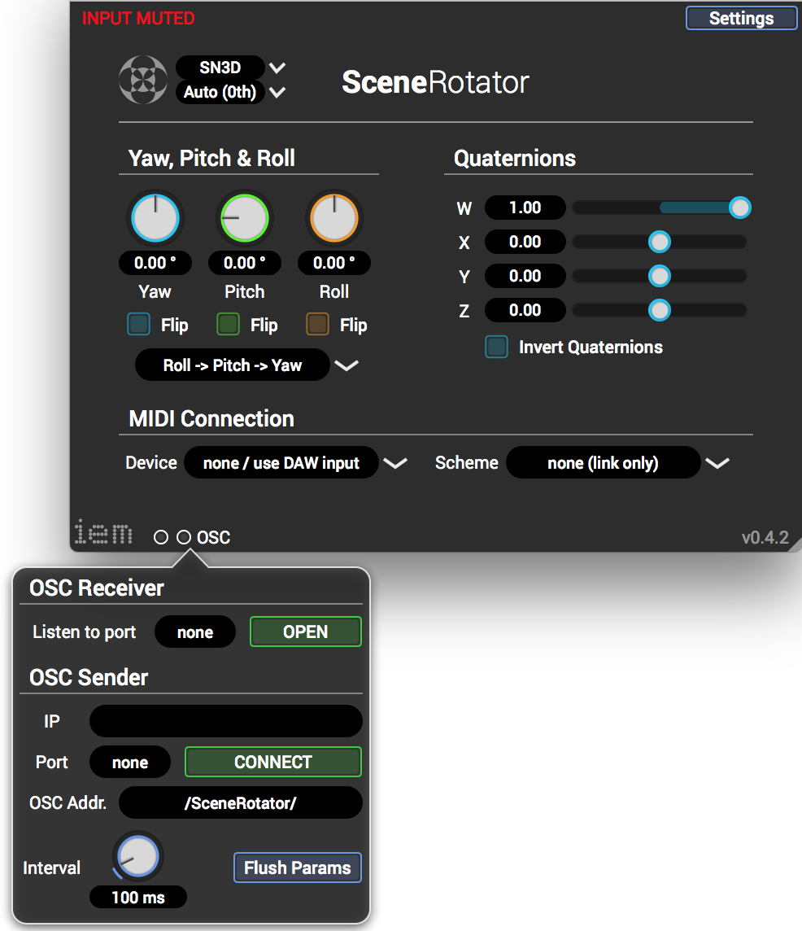



### **Step 5:** Setting up the OSC-Receiverin the SPARTA Plug-Ins

• [**Sparta Plug-ins**](http://research.spa.aalto.fi/projects/sparta_vsts/plugins.html)plug-ins for spatial audio production **(**[**http://research.spa.aalto.fi/projects/sparta_vsts/plugins.html**](http://research.spa.aalto.fi/projects/sparta_vsts/plugins.html)**)**

**Step 5.1:** Select the correct OSC port (bottom left corner see figure 26)

**Step 5.2:** Enable Rotation or R-P-Y



